UNIT 1

1.1 Introduction to Mobile Application
In the modern age of Information and communication system, people are habituated to use computer and computer application. But Mobile Application uses and development is a new and rapidly growing sector. There is a global positive impact of mobile application. Using mobile application developed country are becoming facilitate and people, society of developing country are upgrading themselves and making a new type of IT infrastructure. Mobile applications are running on a small hand hold mobile device which is moveable, easy to use and accessible from anywhere and any place. Now a day, so many people are using mobile application to contact friends, browse internet, file content management, document creating and handling, entertainment etc.
The mobile application run in a mobile environment which usability depends on several factors such as: Screen resolution, Hardware limitations, Expensive DaInteraction possibilities. A mobile application, also referred to as ta Usage, Connectivity issues, Limited a mobile app or simply an app, is a computer program or software application designed to run on a mobile device such as a phone, tablet, or watch. Mobile applications are consisting of software/set of program that runs on a mobile device and perform certain tasks for the user. The mobile application has wide uses for its vast functioning area like calling, messaging, browsing, chatting, social network communication, audio, video, game etc. s. From the technical point of view the different mobile applications are run able in different managed platforms like iPhone, BlackBerry, Android, Symbian, windows. Mobile Applications are separated into three general categories: native applications, web apps and hybrid applications.

1.2 History of Mobile Application
As integral to our lives as they’ve become, it wasn’t that long ago that mobile apps were a rarity. At first the mobile application comes as a simplest way with our early cell phones, alarm clocks, currency calculators etc. At that time people just used mobile application for receiving call messaging, doing simple calculations etc. In 1997, the Nokia 6110 included a built-in version of the basic arcade game “Snake,” which many consider the first mobile app. So, after that back in 2000 mobile application developers were planning to introduce internet based mobile application. With the help of such mobile application people can connect to the internet for daily importance work.
The Motorola DynaTAC 8000X was the first commercially available cell phone. The Motorola DynaTAC 8000X commercial portable cellular phone received approval from the U.S on September 21, 1983. At first, mobile users only had access to simple, though sometimes difficult to use, apps such as calculators, ringtone creators, basic arcade games and calendars. The app development was in-house only. Still, mobile companies tried to offer customers more apps via the Internet by using the Wireless Application Protocol (WAP). Moreover, the early phone used to have a limited storage and processing power so they couldn’t handle the data- intensive operations required by traditional Web browsers. The bandwidth requirements for data transmission were also costly to the user.
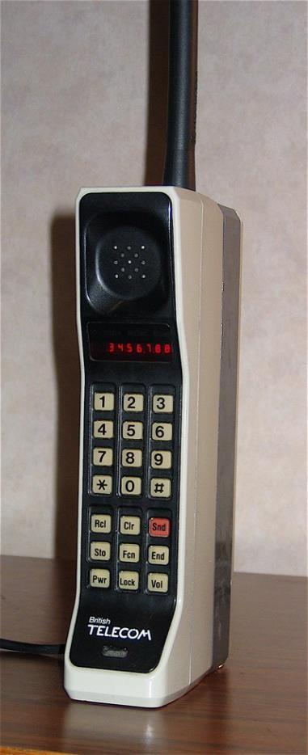
WAP was a stripped- down version of HTTP, which is the basic protocol of the World Wide Web. Most of the early WAP sites were extensions of popular branded Web sites, such as CNN.com and ESPN.com. WAP was not a solution. By 1993, IBM attempted something new, a mobile device with a touchscreen. Simon, as it was named, included access to preinstalled apps for the tasks users wanted most, such as a calendar, clock, notepad, email, contacts, games and even fax. RIM (Research in Motion India) built upon this success with the first Blackberry that was dedicated to email, a still widely used app. In 2007 and 2008 when Apple released the first iPhone followed by the App Store. Suddenly, users had access to an entire marketplace of apps that were easy to access and install. HTC released the first commercially available Android phone the same month, giving Apple competition just months after their own releases. Both markets quickly reached one billion app downloads with Apple hitting the mark in 2009 and Android just a year later. During this time, Apple also changed the game by releasing the iPad, giving users yet another way to use apps.

Fig: Motorola Dyna TAC 8000X
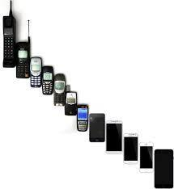
Fig: Evolution of cell phones from 1G to 5G

By 2011, there were over one million apps available, and app usage finally surpassed mobile web usage. In the years that followed, Apple and Google saw their marketplaces’ popularity soar with over 15 billion downloads a piece. Popular apps such as Draw Something and Instagram reached over 50 million downloads and the viral game, Angry Birds, has over one billion downloads. The open platforms make it easier for app development companies to create and market their apps to numerous devices. By looking at the history of app development, app developers can learn what types of apps users want most. With every suddenly popular app, developers have yet another chance to create a better version. With every device released, developers have a new way to display apps.

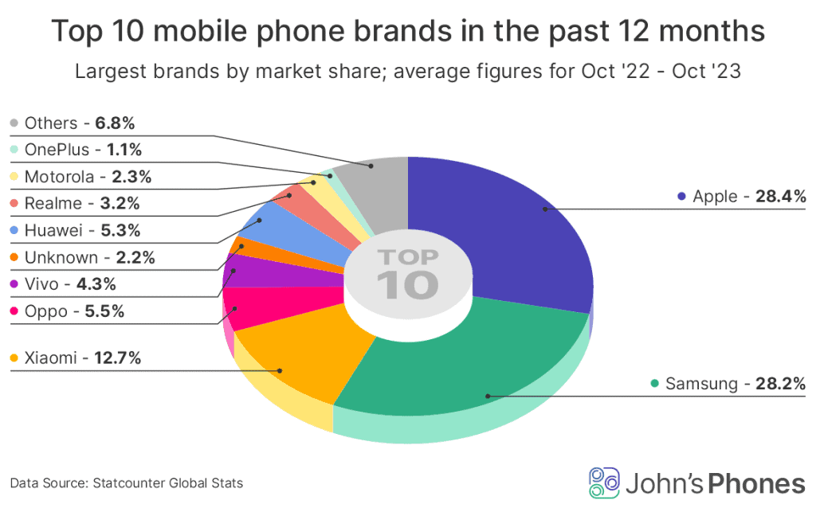
Fig: Report from 2022-2023

1.3 Mobile App Distribution Platform
App distribution platform is the process of releasing an app to a broad set of users in order to promote app engagement and usage. The list of mobile app distribution platforms includes digital distribution platforms, or marketplace 'app stores', that are intended to provide mobile applications, aka 'apps' to mobile devices. A mobile app distribution platform holds the collection of mobile apps in all categories like entertainment, shopping, games, etc. This platform offers mobile users to search their favorite app and download anytime. Almost every mobile app development company targets these platforms while launching applications. Utilizing different application distribution platforms helps companies to reach out to more users across the globe.
Note: It’s not always possible to upload an app to every platform, since some are only available to certain operating systems, like the App Store for iOS and Google Play for Android.

1.3.1 Google Play
Google Play, formerly known as Android Market, is the official app store for devices running on Android OS and has over 3.48 million apps available as of 2021, making it the largest app store on the market. Google Play is the official mobile app distribution platform for Android gadgets and users. For developers to distribute and manage apps in Google Play, they’ll need to pay a one-time $25 fee. Play Store is Google's official pre-installed app store on Android-certified devices. It provides access to content on the Google Play Store, including apps, books, magazines, music, movies, and television programs.

1.3.2 App Store
Apple Inc. has developed the App Store which opened its doors in 2008 and is another one of the biggest and most widely used mobile app distribution platforms for iOS. This digital distribution channel enables users to install apps developed in the iOS software development kit. Likewise, the applications can be downloaded on the iPhone mobiles, iPads, iPods, Apple Computers, Apple Watch, Apple TV, and some more. There are various categories available on the Apple App Store for millions of users: App Store iOS is a secure distribution platform for mobile apps. It is easy to use. Owing to this, businesspeople prefer getting their apps developed in the iOS environment.

1.3.3 Windows Store
Windows Phone Store (previously Windows Marketplace) was an app store, developed by Microsoft corporation for Windows Phone letting users installing various apps on their device. It initially launched with Windows Phone 7 in October 2010. In 2015, Microsoft announced that Windows Phone Store would be killed out and replaced by Windows Store which would act as a unified store for all Windows-powered devices. Windows Phone Store supported credit card purchases, operator billing, and ad-supported content. The store also featured a "try-before-you-buy" option, where the user had an option to download a trial or demo for a commercial app.

1.3.4 Google Assistant
Google Assistant are the most common and extensively used Intelligent Personal Assistants available in the market. From the academic perspective, they are Speech-based Natural User Interfaces (NUI). In the Human-Computer Interaction (HCI) domain, speech-based NUIs are systems that users operate through intuitive actions related to natural human behavior via voice instructions. Google Assistant is an intelligent personal assistant developed by Google. It was designed to allow conversational usage. Google Assistant’s predecessor is Google Now. Google Assistant is linked with Google Home, a voice-activated speaker. Assistant initially debuted in May 2016 as part of Google's messaging app Allo, and its voice-activated speaker Google Home. After a period of exclusivity on the Pixel and Pixel XL smartphones, it began to be deployed on other android devices in February 2017, including third-party smartphones and Android Wear (now Wear OS), and was released as a standalone app on the iOS operating system in May 2017. A remarkable feature of Google Assistant was the naturalness of answering some questions. The tone and pace of the female voice used by the Google device expressed surprise, suspense and joy. These features were no always offered by Siri, Cortana and Alexa.

1.3.5 Siri
Siri is a personal assistant for Apple devices iOS, iPadOS, watchOS, macOS, and tvOS operating systems. Originally released in 2010, it is the oldest of the most used intelligent personal assistants. The most common uses for Siri are web browsing and dictation. Some of the promotional commands for Siri include: “What movies are playing today?”, “Find videos I took at Iva’s birthday party”, “Text Pete ‘See you soon smiley exclamation point’”, “Read my latest email”

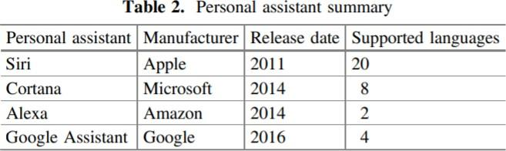

1.4 Mobile Application Vs Application Software
Application Software
Application is a software that performs specific tasks for an end-user. It is also known for performing specific single task. It is capable of dealing with user inputs and helps the user to complete the task. It is also called end-user programs or only an app. effectively, if the user is interacting directly with a piece of software it is application software. For example, Microsoft Word or Excel are application software, Database Management tools, IDE as are common web browsers such as Firefox or Google Chrome.
Mobile Application
A mobile application, also referred to as a mobile app or simply an app, is a computer program or software application designed to run on a mobile device such as a phone, tablet, or watch. A mobile application, most commonly referred to as an app, is a type of application software designed to run on a mobile device, such as a smartphone or tablet computer. Mobile Application are generally small, individual software units with limited function.

Difference between mobile application and application software

Feature | Mobile Application | Application Software
Definition | Software designed to run on mobile devices like smartphones and tablets. | Software designed for general-purpose computing on desktops or laptops.
Platform | Mobile operating systems like iOS and Android. | Desktop operating systems like Windows, macOS, and Linux.
User Interface | Optimized for touch interfaces with smaller screens. | Designed for larger screens with keyboard and mouse interactions.
Distribution | Typically distributed via app stores (e.g., Apple App Store, Google Play). | Usually distributed through websites or physical media.
Installation | Installed from app stores or direct downloads; often has app permissions. | Installed from a variety of sources, including downloads or CDs/DVDs.
Connectivity | Often requires internet connectivity for full functionality, though some apps work offline. | May function offline, though many modern applications integrate with online services.
Development Languages | Java, Kotlin (Android), Swift, Objective-C (iOS). | C++, Java, .NET languages (e.g., C#, VB.NET), Python, etc.
Updates | Regular updates via app stores; users are often prompted automatically. | Updates may require manual download and installation or use of update managers.
Resource Constraints | Limited by mobile device resources (e.g., CPU, memory, battery life). | Typically designed to utilize more powerful hardware resources of desktops.
Performance | May be optimized for performance and battery efficiency due to hardware limitations. | Can take advantage of more robust hardware and may offer higher performance.
Examples | Social media apps (Facebook, Instagram), games, weather apps. | Office suites (Microsoft Office, LibreOffice), graphic design software (Adobe Photoshop).
Security | App permissions and sandboxing to restrict access to system resources. | May have more robust security features but depends on the OS and software design.
User Experience | Designed for quick interactions and on-the-go usage. | Designed for more in-depth and prolonged usage.
Monetization | Often monetized through in-app purchases, ads, or subscription models. | Typically sold via licensing, subscriptions, or one-time purchases.

